Staining Method
Routine Histology Staining Method
Hematoxylin and Eosin Staining Method
Wright-Giemsa Staining Method
Special Histology Staining Method
Acid Fast Bacillae Staining Method
Alpha Naphthyl Esterase Staining Method
Beta Catenin Staining Method
Chloroacetate Esterase Staining Method
Cytokeratin-14 Staining Method
Cytokeratin-18 Staining Method
Cytokeratin-8 Staining Method
Diff-Quik Staining Method
E-Cadherin Staining Method
Elastin Staining Method
Gram Staining Method
Her2/erbb2/neu Staining Method
Immunohistochemistry Staining Method
Iron Staining Method
Laminin Staining Method
Methyl Green Pyronine Staining Method
Mucin 1 Staining Method
Mucin 2 Staining Method
Osteopontin Staining Method
Periodic Acid Schiff Staining Method
Polyoma Virus Middle T Staining Method
Silver Staining Method
Smooth Muscle Actin Staining Method
Staining for Viral Inclusions
Staining of Sputum for Pneumocystis
Synaptophysin Staining Method
Synaptophysin and Hematoxylin Staining Method
Trichrome Staining Method
Warthin-Starry Staining Method
Whey Acidic Protein Staining Method
Wilson's Staining Method
c-Myc Staining Method
in situ Hybridization Staining Method

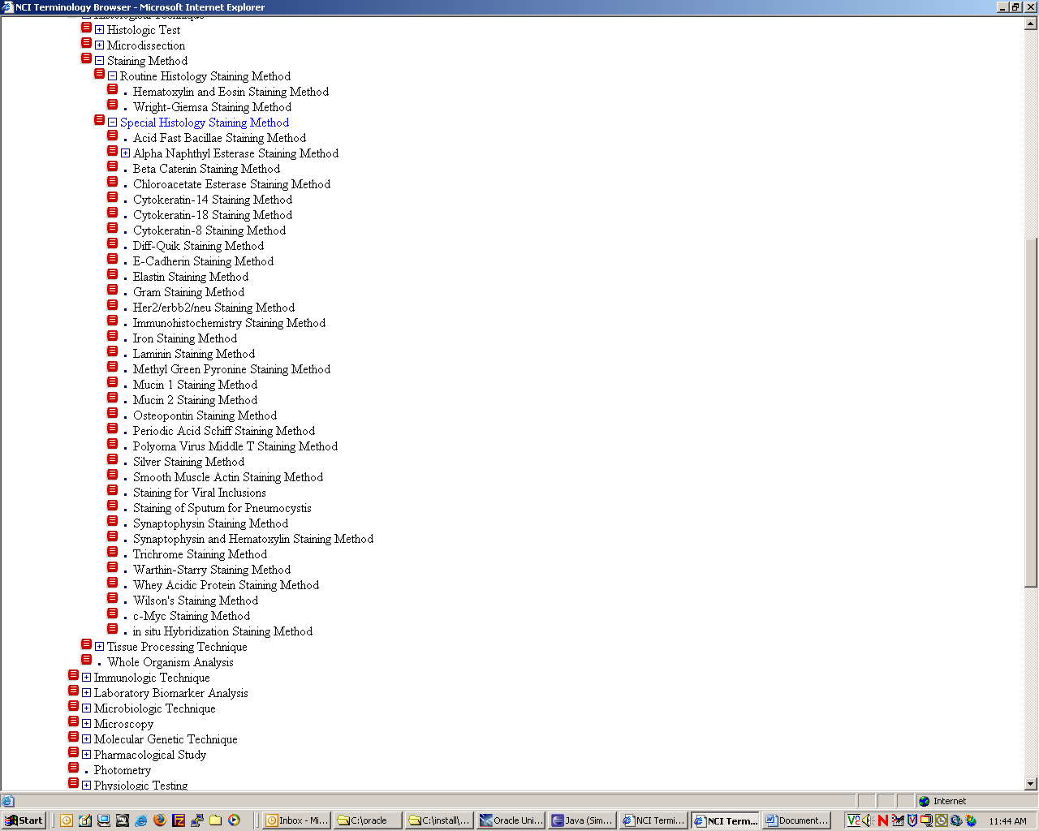
submitHistopathology code

<tr>

<td class="formRequiredNotice" width="5">*</td>
<td class="formRequiredLabel"><label for="field1">Site of Lesion/Tumor:</label>&nbsp;
<camod:cshelp topic="data_tree_help" key="ORGAN.CONCEPT_CODE" image="images/iconHelp.gif" text="Tool Tip Test 1" />

<a href="javascript:showMouseTissueTree('histopathologyForm', 'organTissueCode', 'organTissueName', 'organ', true)">
<IMG src="images\selectUP.gif" align=middle border=0>
</a>
</td>
<td class="formField">
<html:hidden property="organTissueCode"/>
<input type="hidden" name="organTissueName" />
<html:text styleClass="formFieldSized" disabled="true" property="organ" size="30" />
</td>
</tr>

